**Project Report**

**Data Structures**

**Contributor:**

**Talha Shahid [21K-3355]**

**PROJECT TITLE:**

**“Plagiarism Detector”**

* **Abstract:**

Copying and theft of content are becoming a new norm in society, and this has arisen a need for a system or program to maintain checks and balances to ensure the originality of content. To cater to and resolve this problem we have created a program that checks for plagiarism and is also very easy and safe to use. Our priority was to deliver a system that is not only user friendly but also highly secure. We have implemented several data structures in this project which will be discussed further on. As a result of this project, we have developed an efficient program for plagiarism and named it "PLAGIARIZM.IO".

* **Introduction:**

Plagiarism’s meaning comes from the Latin word ‘plagiarius,’ which means to kidnap. When someone uses the work of another writer or artist without properly citing the source or giving credit, that’s plagiarism. That’s why it’s important to know what plagiarism is and utilize plagiarism checker tools to check and protect your work.

* **Working:**

A plagiarism checker uses advanced database software to scan for matches between your text and existing texts. The texts are entered into the system, and it automatically saves them into a text file and gives each entered text a unique ID that can be easily identified if a match occurs. They are commonly used by universities to scan student assignments.

* **Methodology:**
  + **Working Diagram:**

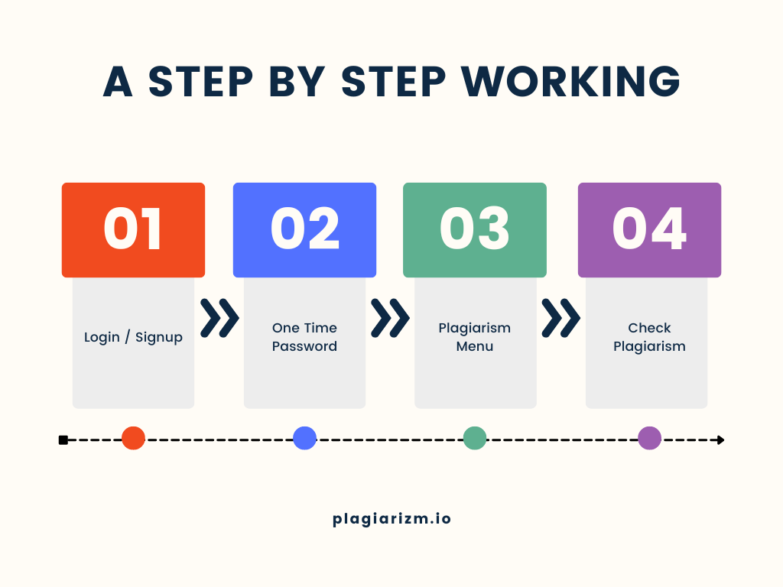

* + **Data Structures Implemented:**
    - Stacks: Implementation of stack has been done in Check Plagiarism Function. When a plagiarism has been detected the matching similarities will be pushed into the stack and then popped at printing.
    - Linked List:The implementation of stack has been done using linked list.
    - Arrays: Arrays are being used throughout the program to store input and also for output and string comparisons.
* **Objective:**

The objective was to make an easy to use, light, efficient and secure program to check and identify plagiarism in content. This program will come in handy for the Teachers and Teacher Assistants (TAs) for assignment and quiz checking since it was specifically catered to meet their needs and requirements.

* **Results & Discussion:**
  + **Main Menu:**

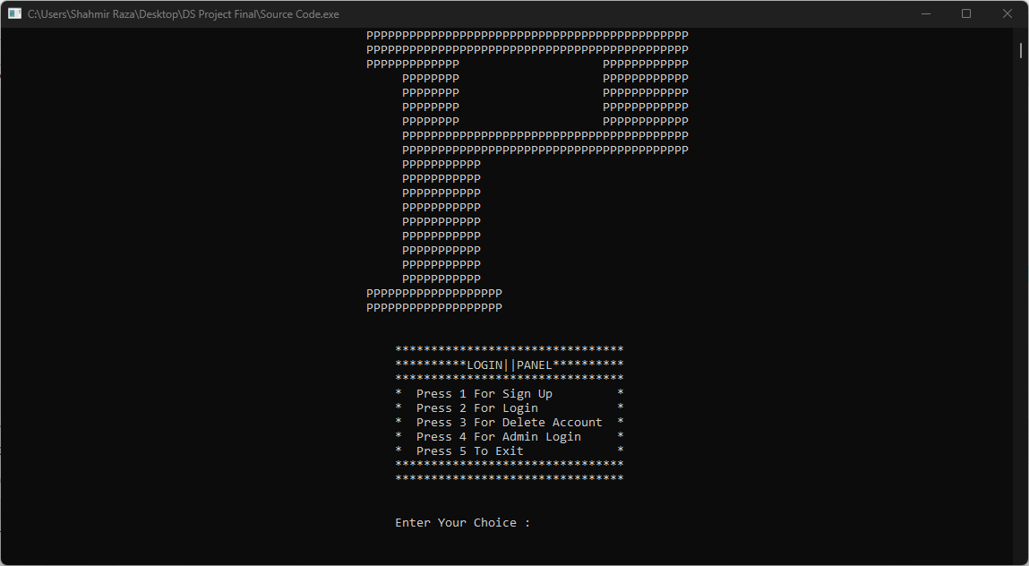

* + **Sign Up:**

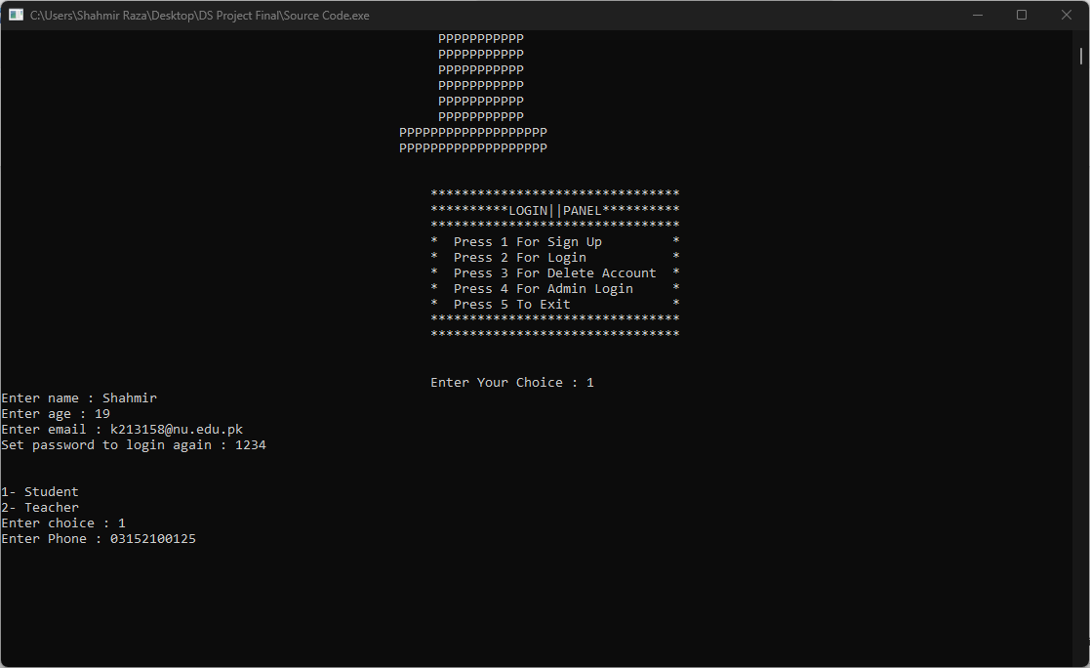

* + **Welcome Email:**

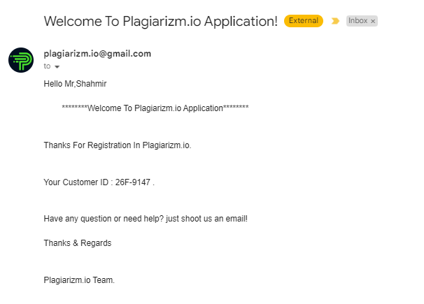

* + **Login:**

* + **One Time Password (OTP) Email:**

* + **One Time Password (OTP):**

* + **New Login Email:**

* + **Plagiarism Menu:**

* + **Plagiarism Checking:**

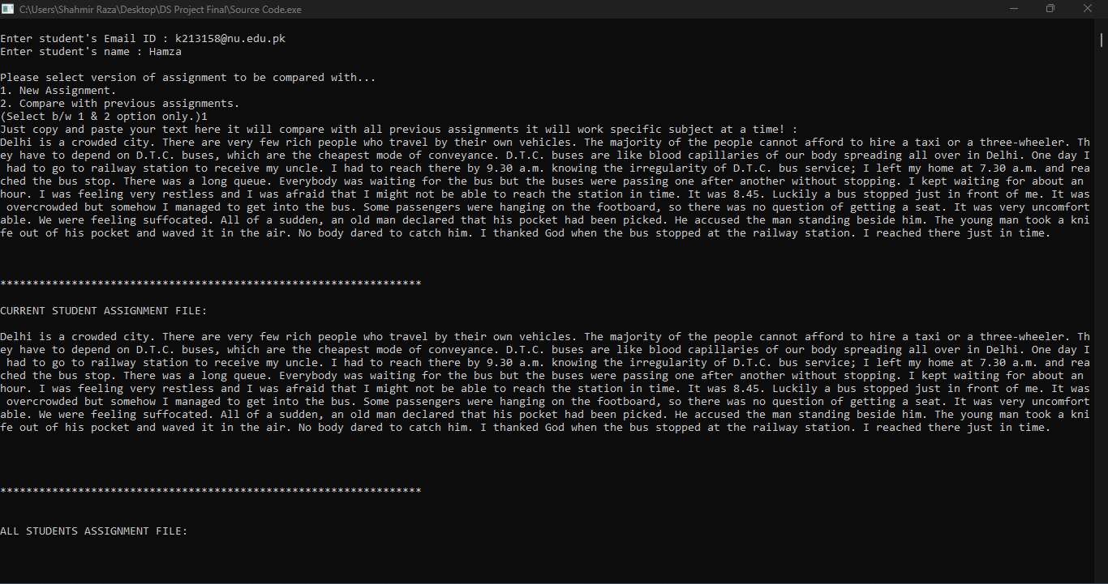

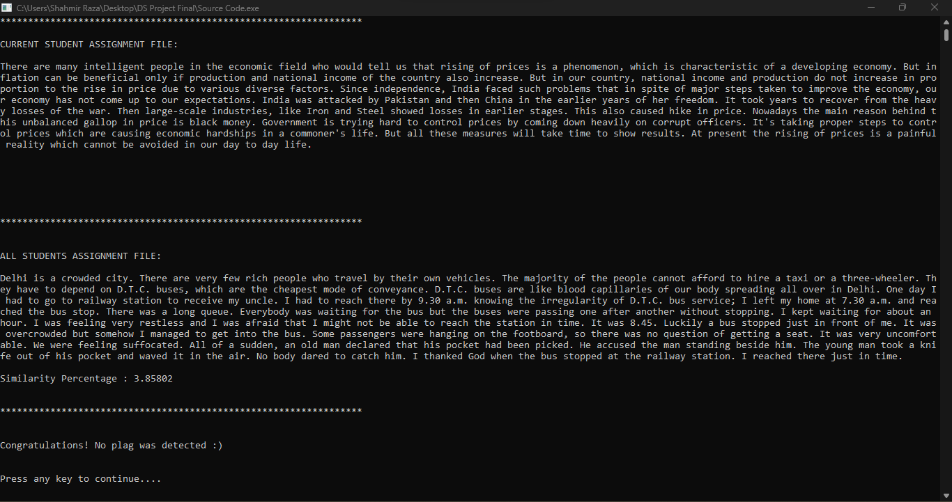

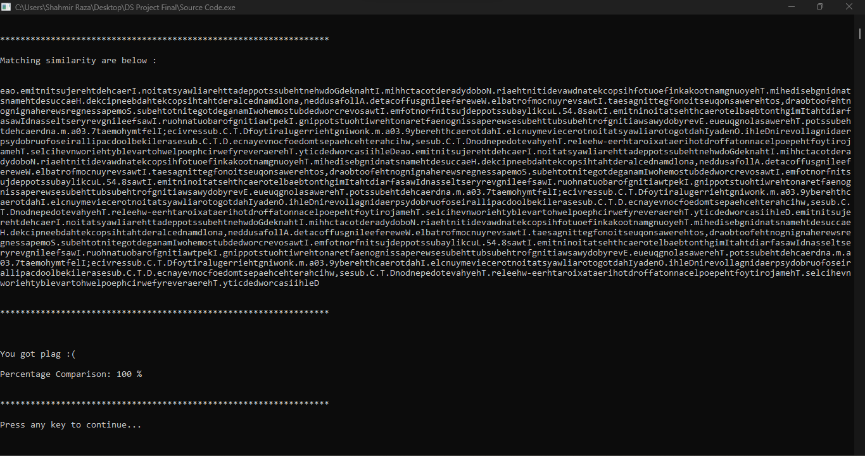

* + **Plagiarism Detected Email:**

* + **Show Details:**

* + **Show Added Assignments:**

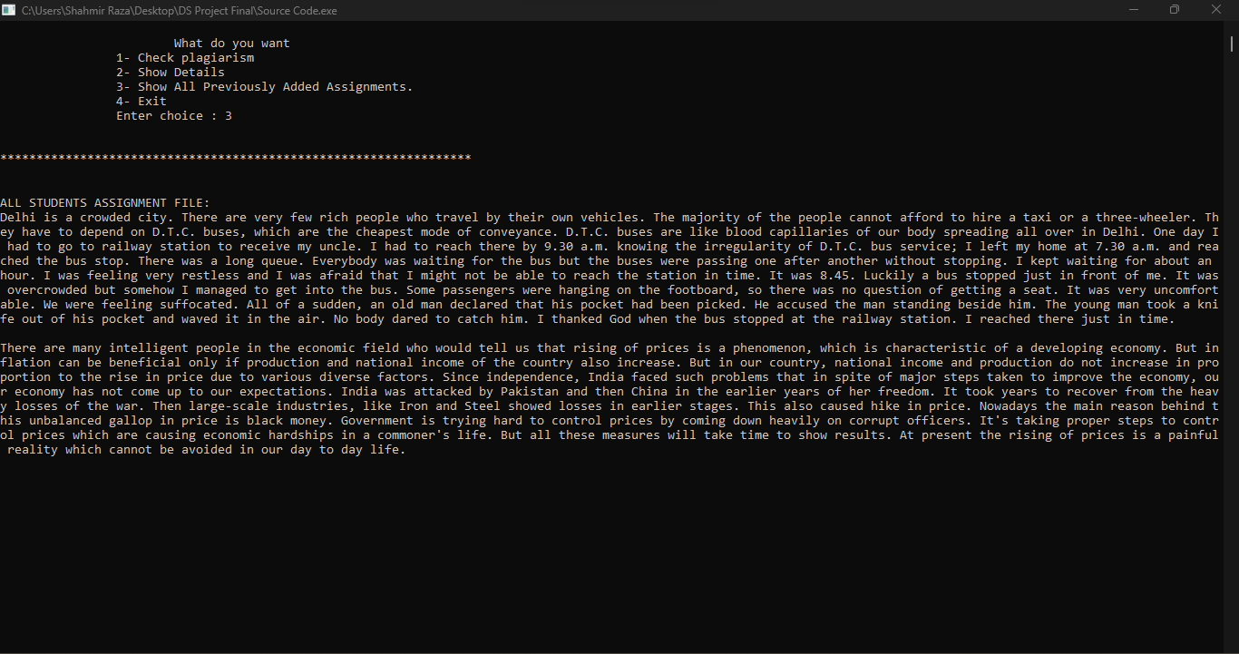

* + **Account Delete:**

* + **Account Delete Email:**

* **Conclusion:**

In the end we hope that the project that we have worked on is up to the mark and performs as expected. We hope our efforts to end copyright infringement will bear fruit and more and more people will adopt such programs for plagiarism detection.